1. The same we discussed in Hammer, Bullish Engulfing and Piercing Pattern.
2. 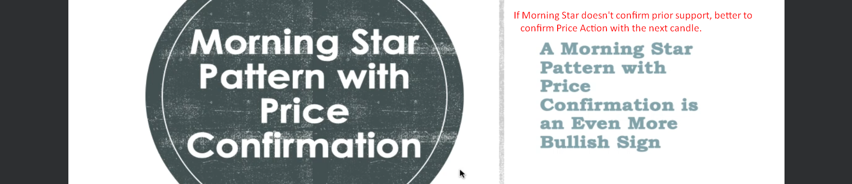  
   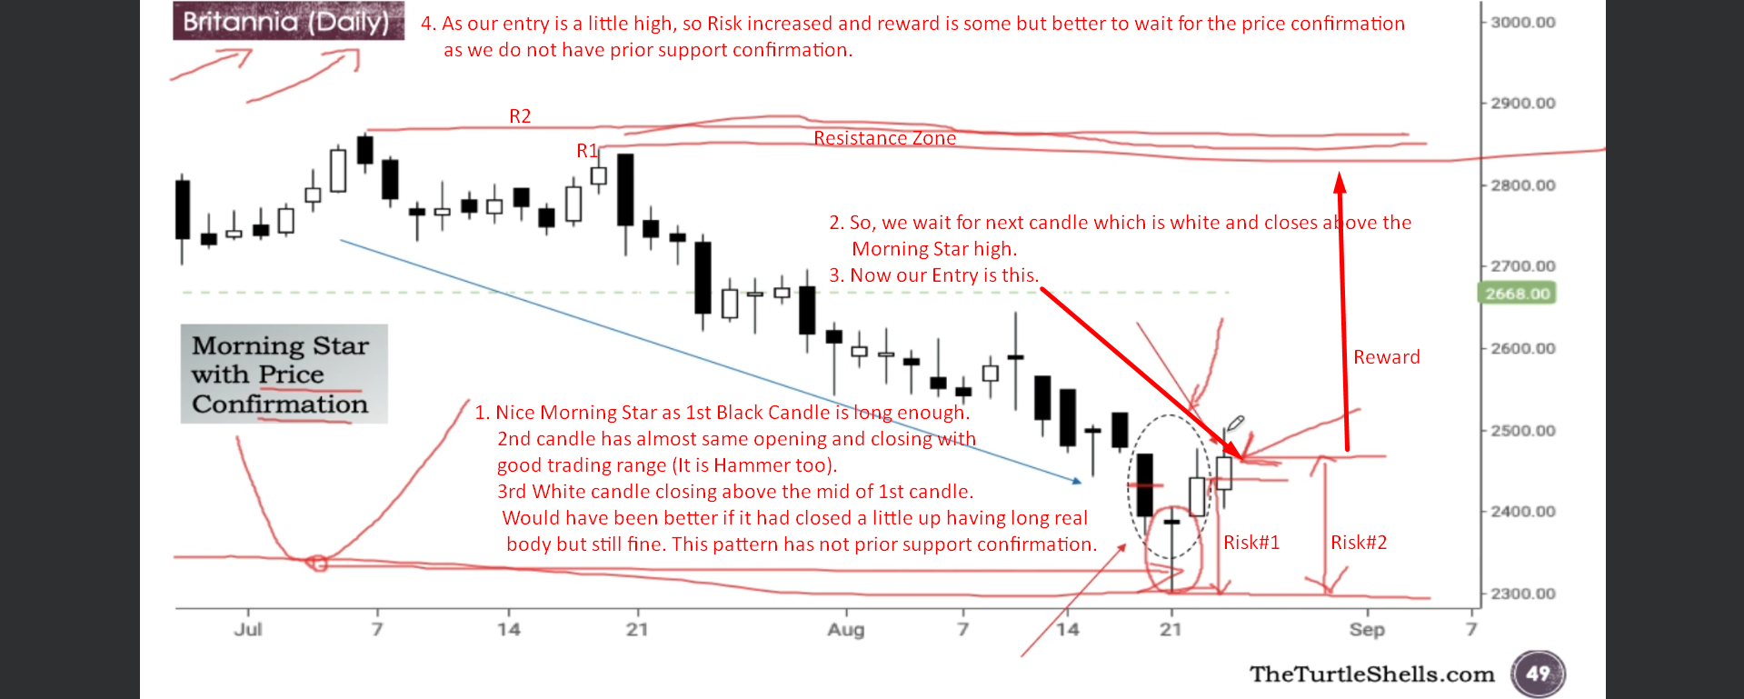
3. 